
Year 12 PHYSICS ATAR 2017

Semester 1

Task 7: Test 2

TASK TYPE: Test

CONTENT: Gravity, circular motion and torque – 6%

 | Possible Marks | Your Mark
Total | 50
Percentage | 100%

Student Name: ____________________________________

Date: ____________________________________

Teacher: J. Wijaya

Instruction:

- Answer all questions.

- All numeric answers are to be corrected to three significant figures unless specified. Estimated answers are to be corrected to two significant figures.
- Kepler’s 3rd law of planetary motion is:
$$T^{2}= \frac{{4π}^{2}}{GM} r^{3}$$
Derive this formula using at least two other equations from the supplied data sheet. Show ALL steps in your working.
[3]

- Explain why very tall trees growing in a windy environment require a stronger and more extensive root system than similar, but shorter, trees to resist being blown over.
[4]

- A velodrome is an oval-shaped cycle track, parts of which are steeply banked. The riders on this track are travelling at 15.0 m s⁻¹, the radius of curvature of the banked track is 35.0 m and there is no tendency for the bikes to slide up or down the slope.
track
cyclist
θ

  - On the diagram, label all forces including the net force. Then explain the benefits of banked curve using physics concepts you have learnt.
[4]

  - Calculate the angle of the bank, θ.
[3]

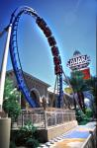
- The photograph on the right shows a rollercoaster negotiating a vertical circular loop.
21.0 ms⁻¹
radius = 10.0m
The dimensions of the loop and the rollercoaster’s speed at the bottom of the loop are shown in the diagram below:

  - Describe the apparent weight of an occupant of mass 60.0kg when the rollercoaster is at the bottom of the circular loop. Support your answer with a calculation.
[3]

  - Calculate the minimum speed at the bottom of the circular loop so that the rollercoaster is just in contact to the top of the loop.
[5]

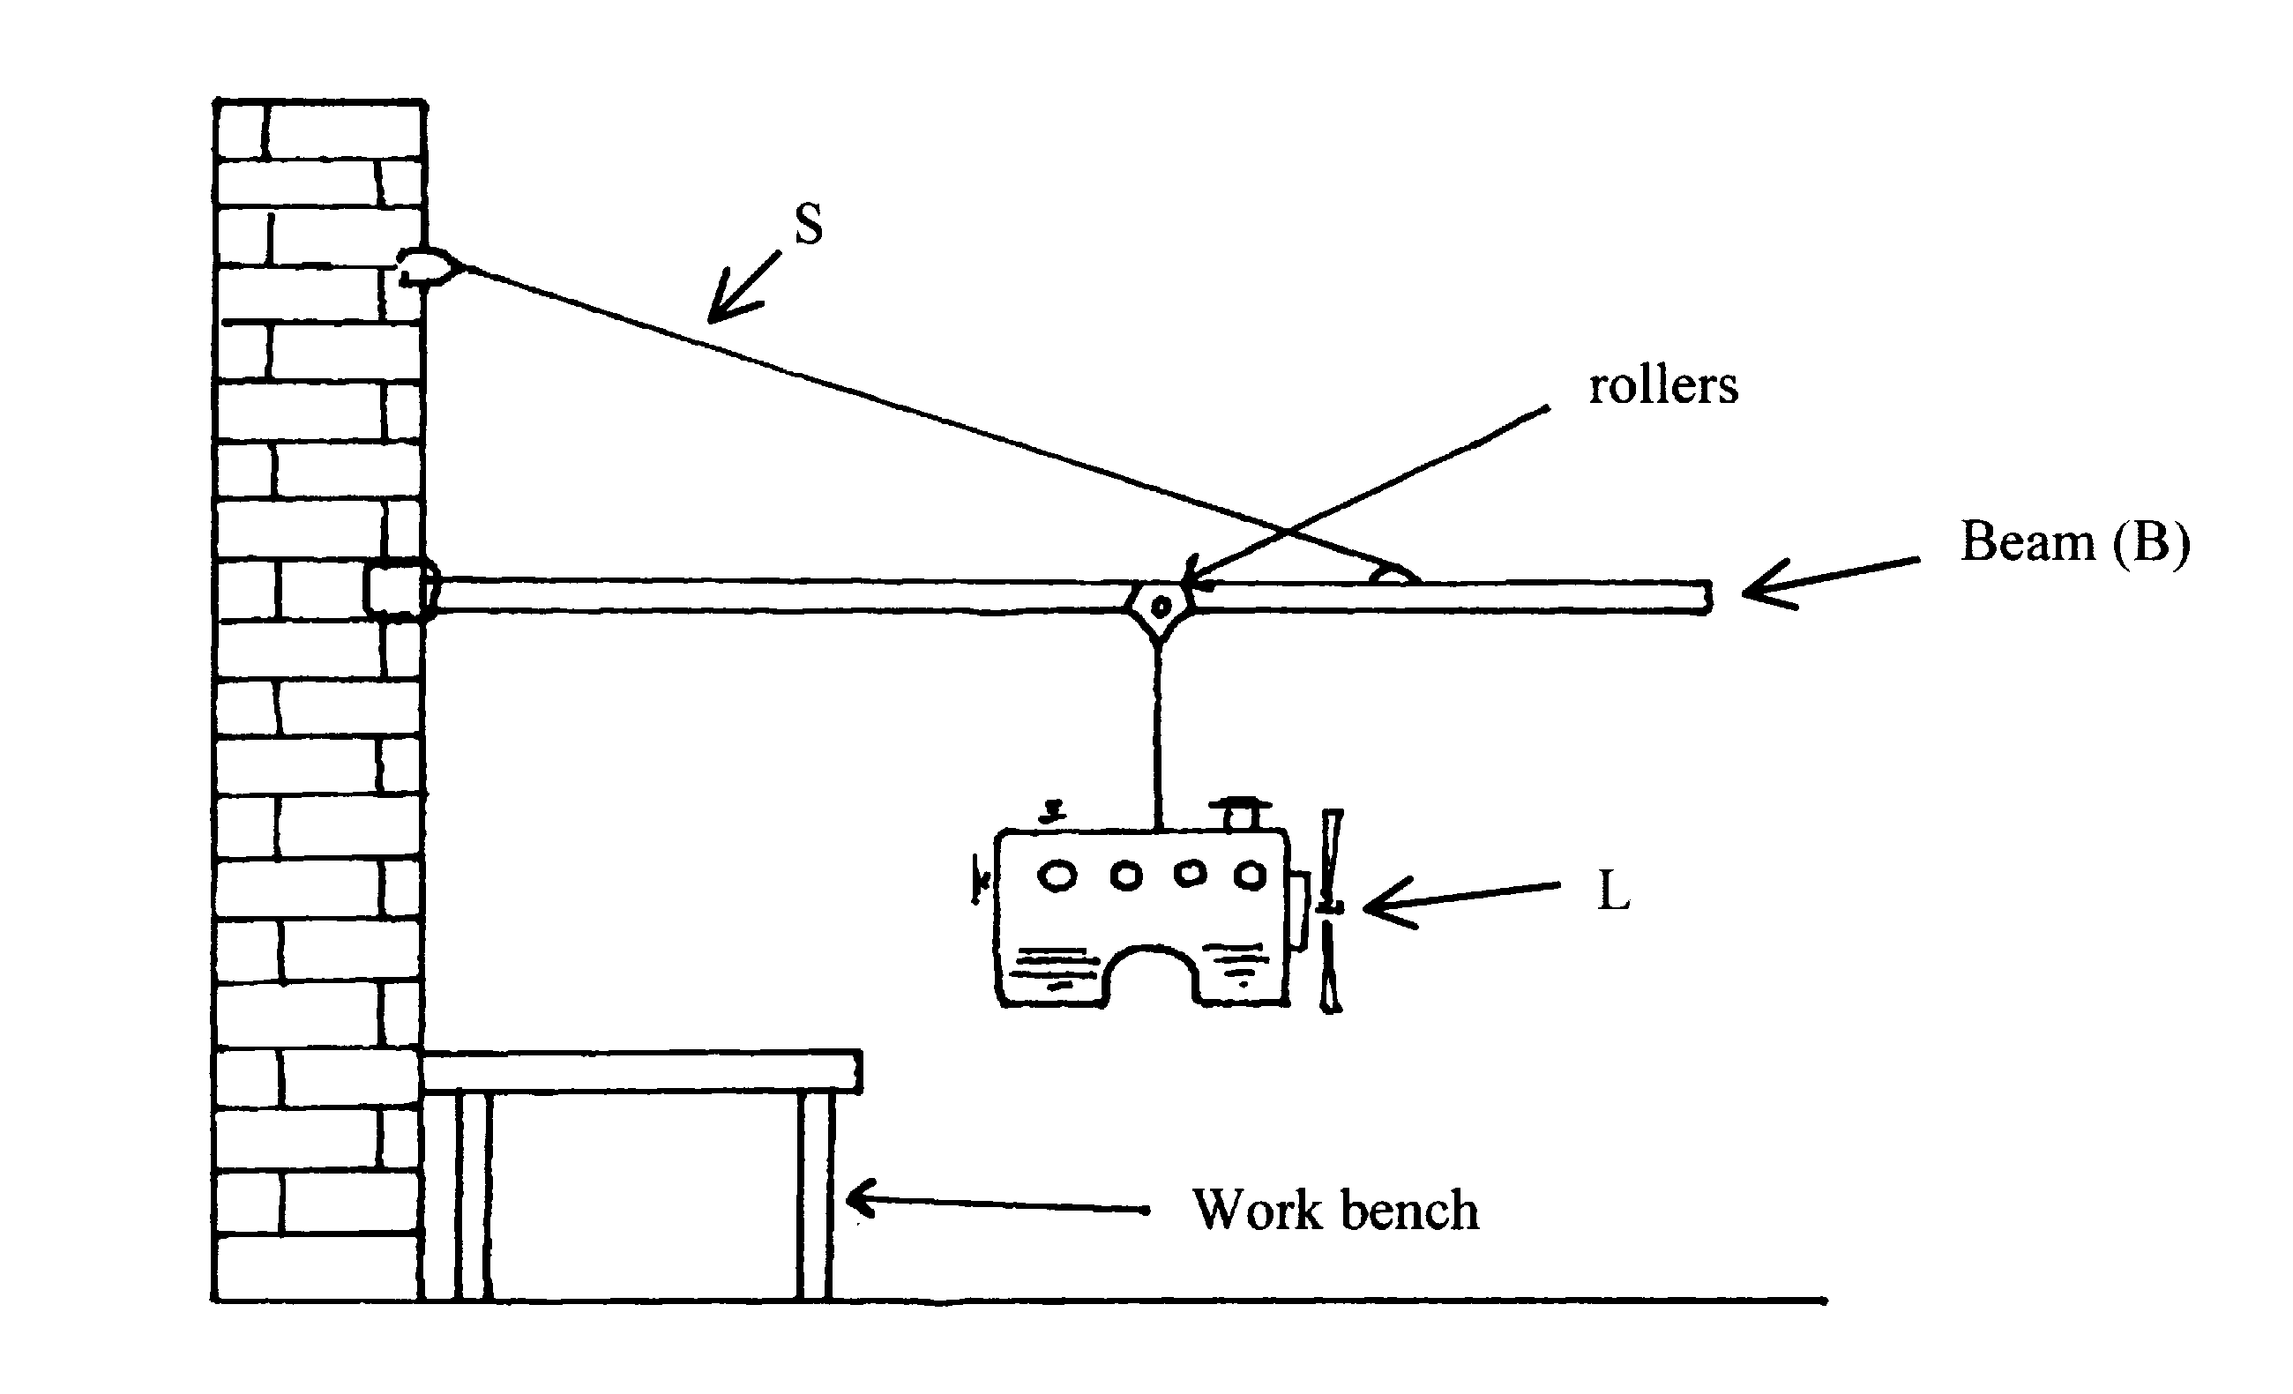
- The wall crane is designed to lift motors from cars and transfer them to a workbench. It uses rollers to allow the operator to shift the load from one end of the beam to the other as shown in the diagram. The beam (B) is 3.0 m long and the support wire (S) is attached 0.5 m from the outer end at 25.0° to the beam. That is, the angle between S and B is 25.0°.

  - Calculate the tension S. When the load is 0.25 m from the right end.
[5]

  - What would happen to the tension S if the load was gradually being moved toward the end of beam (away from the wall)? Explain your answer.
[3]

Continue Question 5

  - Calculate the reaction force applied on the beam from the wall.
[5]

- Neptune has several moons, two of which are Triton and Nereid. Use the following data to answer Parts (a) to (d) where necessary.

QUANTITY | DATA
Mass of Triton | 2.14 x 10²³ kg
Radius of Triton | 1.35 x 10⁶ m
Mass of Neptune | 1.02 x 10²⁶ kg
Period of Triton's orbit | 5.08 x 10⁵ s
Radius of Nereid's orbit around Neptune | 5.51 x 10⁹ m

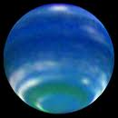

  - A spacecraft is at rest on Triton's surface. One of the experiments on board involves a 10.0 kg mass hanging at rest from a spring balance. The scale of the spring balance is correctly calibrated in Newtons. What is the reading on the spring balance? Show your working.
[2]

Continue Question 6

In parts b), c) and d), the spacecraft (mass 2.00 x 10³ kg) is in a circular orbit with its engines off at an altitude of 2.70 x 10⁶ m above Triton, as shown in the diagram.
Triton
Spacecraft
2.70 x 10⁶ m

In physics terms, describe what is meant by being in 'orbit'? [2]

  - Calculate the gravitational field strength at this altitude due to Triton.
[3]

  - The 10.0 kg mass is still attached to the spring balance as before. What is the reading on the spring balance now? Give reasons for your answer.
[3]

Continue Question 6

The orbital period of Nereid around Neptune is approximately the same as that of the Earth around the Sun (that is 365.25 earth days).

  - Calculate the average orbital speed of Nereid around Neptune.
[2]

  - The length of one day on Neptune is 16 hours, 6 minutes and 36 seconds. Calculate the altitude of a geosynchronous orbit around Neptune. Show all working.
[3]

End of the test

